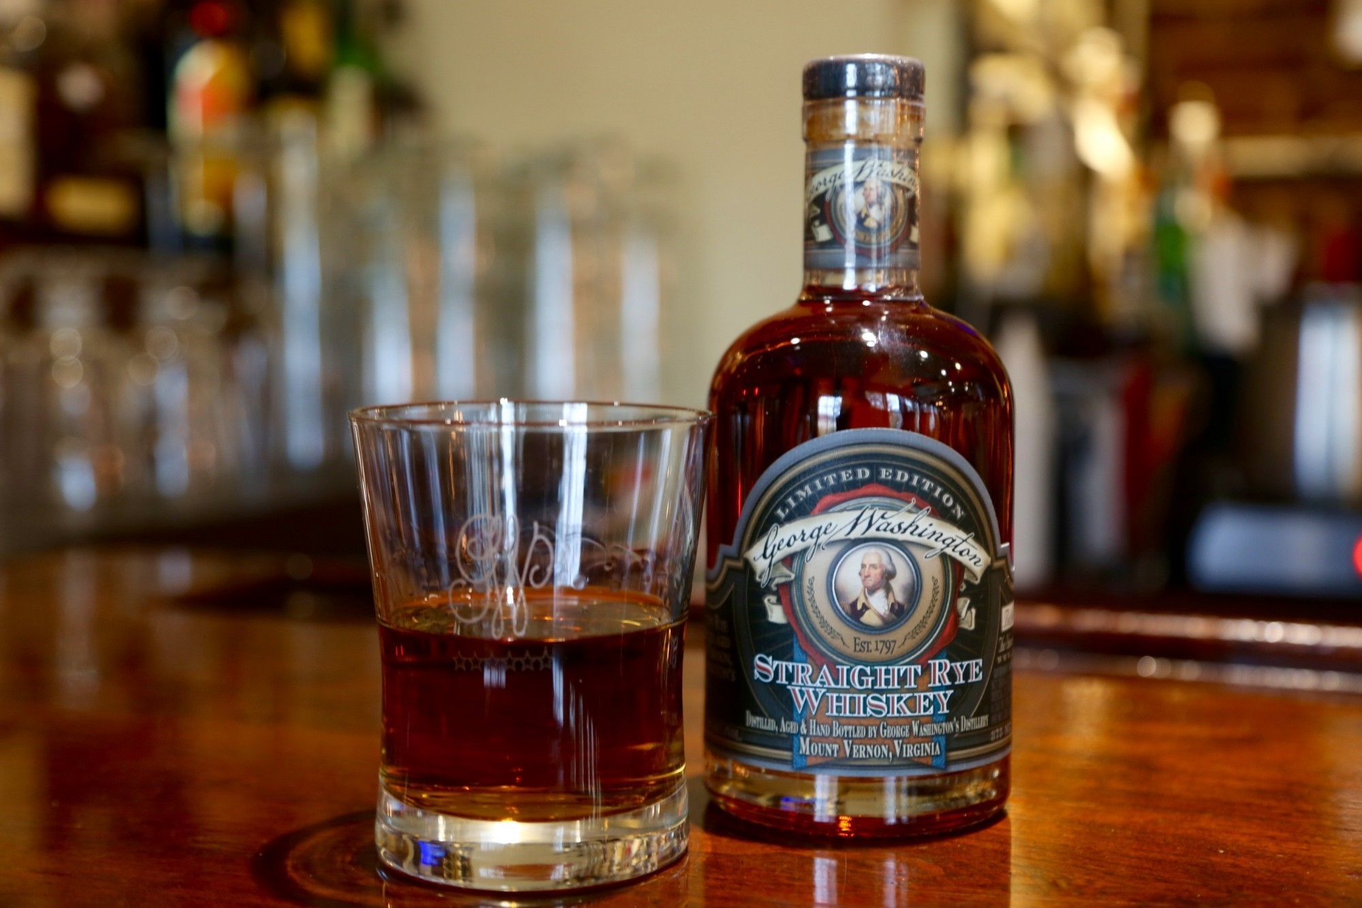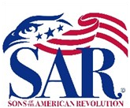

Battle Born Patriots Chapter

Sons of The American Revolution

Rare Opportunity Drawing
The Winner will receive:
- 1-375ml bottle of George Washington’s Straight Rye Whiskey. Distilled, aged & bottled by hand at George Washington’s Distillery, Mt. Vernon, Virginia. This whiskey can only be purchased in person at Mt. Vernon. The 375ml bottle retails for $235 and is never discounted.
- 2 Rocks Glasses etched on clear glass with a the SAR logo.
- The proceeds from this drawing will all be used to support the Battle Born Patriots Chapter Color Guard and to support the Chapter's patriotic educational outreach programs..

Only 120 tickets will be sold! The Drawing will be held at the observation of the anniversary of the Battle of Lexington/Concord on Saturday April 18, 2026. The Winner need not be present.

Name:
Address:
Phone:
Email:

Tickets are: ______ 1 Ticket @ $20 or ______ 3 Tickets @ $50.

Check (payable to Battle Born Patriots Chapter, SAR). Mail check to Jim McLane, 1615 Murrieta Ct., Reno, NV 89521]
Credit Card (MasterCard, Visa or Amex) [NOTE: Email your credit card authorization to battleborn.jim@outlook.com]

Credit Card No.: Exp. Date:

CVC Code (from back): Billing Zip Code:
Email (if receipt is requested):

